Architecture Document – Rebound

1. Application
Rebound follows a Serverless Architecture, where the application backend is fully managed by cloud services and does not require maintaining or deploying traditional backend servers.
The application consists of a Flutter-based client that directly communicates with Supabase, which provides backend services such as authentication, database access, file storage, and real-time updates. Business logic is primarily handled on the client side, with critical validations and access control enforced at the database level using security policies.
This architecture was selected due to:
- Reduced infrastructure complexity
- Automatic scalability
- Faster development and iteration
- Cost efficiency for a student project
Although Rebound behaves as a single application from the user’s perspective, the backend services are decoupled and managed independently by the serverless platform.
1.1 Monolithic
Rebound is a traditional monolithic application.
In a monolithic architecture, all components such as UI, business logic, and database access are hosted and deployed as a single backend application. Rebound does not use a single backend server; instead, backend responsibilities are delegated to managed cloud services.
However, Rebound can be considered logically monolithic, as:
- There is a single client application
- A unified database schema
- Centralized authentication and authorization

1.2 Event-Driven
Rebound partially incorporates event-driven principles, but it is not a fully event-driven architecture.
Event-driven behavior is observed in:
- Real-time updates when new game logs or posts are added
- Automatic UI updates using database change subscriptions
- Trigger-based updates such as score approvals reflecting instantly in analytics
These events are handled internally by the backend platform and do not involve external event brokers or message queues.

1.3 Serverless
Rebound primarily follows a Serverless Architecture.
Key characteristics:
- No backend servers are managed by the development team
- Backend services (authentication, database, storage, real-time) are provided as managed services
- The application scales automatically based on usage
- Backend logic can be extended using cloud-based serverless functions when required
This architecture allows Rebound to focus on product functionality rather than infrastructure management, making it ideal for rapid development and scalability.
2. Database
Rebound uses a relational database architecture designed to support structured sports data, role-based user modeling, and performance analytics. The database is normalized for data integrity while also using views and materialized views to optimize read-heavy operations such as dashboards and statistics.
The design separates core identity, role-specific profiles, game data, and analytics, ensuring scalability and flexibility as the application grows.

2.1 ER Diagram
The database revolves around the following core entities:
- Users as the central identity entity
- Athlete and Coach Profiles extending user data based on role
- Teams and Team Memberships defining participation and roles
- Games representing matches between teams
- Player Game Stats capturing per-game performance
- Views and Materialized Views acting as the analytics and read-optimization layer
Relationships:
- One user → zero or one athlete profile
- One user → zero or one coach profile
- Many users ↔ many teams (via team_memberships)
- One game → many player_game_stats
- One player → many game stats across games

2.2 Schema Design
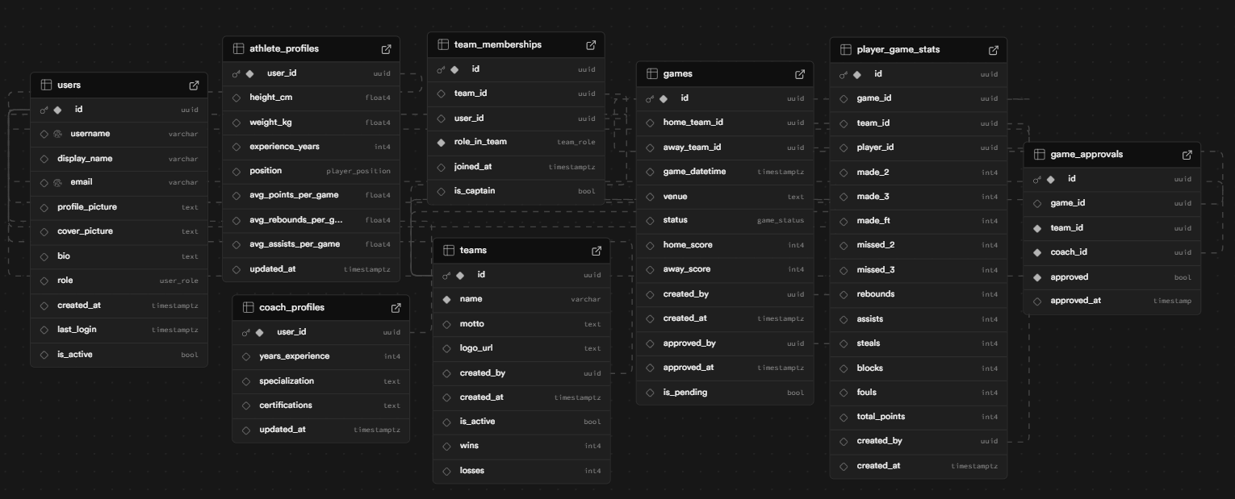

The Rebound database schema is designed using a normalized relational model to ensure data integrity, role separation, and efficient querying. The schema supports user identity management, team structures, game tracking, and performance analytics.
Users
The users table serves as the central identity table and is linked one-to-one with the authentication system. It stores common user attributes such as username, display name, email, role, and profile metadata. This table acts as the parent entity for all user-related data.

Athlete Profiles
The athlete_profiles table stores athlete-specific attributes including physical details, playing position, experience, and computed performance averages. It is linked to the users table through a foreign key. Separating athlete data avoids unnecessary null values for non-athlete users and supports role switching.

Coach Profiles
The coach_profiles table contains coach-specific information such as experience, specialization, and certifications. This separation maintains schema clarity and allows independent evolution of coach-related attributes.

Teams
The teams table represents sports teams within the platform. It stores team identity, branding information, creator reference, and basic status attributes. Teams are created and managed by users.

Team Memberships
The team_memberships table models the many-to-many relationship between users and teams. It assigns roles within teams and enforces uniqueness to prevent duplicate memberships. This design supports flexible team compositions and role-based access control.

Games
The games table stores match-level information including participating teams, schedule, venue, scores, and approval status. It supports an approval workflow to ensure that only verified games contribute to performance analysis.

Player Game Statistics
The player_game_stats table records per-player, per-game performance data. Each record represents a single player’s statistics in a specific game. A unique constraint ensures only one entry per player per game, and computed columns maintain consistency for derived values such as total points.

Views and Materialized Views
Logical views are used to expose only approved and valid data for analysis. Materialized views aggregate player and team statistics to optimize read-heavy operations such as dashboards and performance summaries.

2.3 Data Integrity and Performance Considerations
- Foreign keys ensure referential integrity
- Cascade deletes prevent orphan records
- Unique constraints enforce business rules
- Materialized views improve read performance
- Views enforce approval-based filtering

3. Data Exchange Contract
3.1 Frequency of Data Exchanges
- High frequency:
  - Fetching game logs
  - Updating live scores
  - Loading player and team statistics
- Medium frequency:
  - Post creation and feed updates
  - Team and game creation
- Low frequency:
  - Profile updates
  - Team membership changes
Data exchange frequency depends on user activity and live match interactions.

3.2 Data Sets
The primary data sets exchanged include:
- User profiles (athletes and coaches)
- Team details and memberships
- Game metadata (date, location, teams)
- Game logs and individual player statistics
- Posts and activity updates
- Media files such as team logos and profile images
All data is structured and stored centrally in the database.

3.3 Mode of Exchanges
- API-based communication: CRUD operations via RESTful endpoints provided by the backend platform
- File-based storage access: Used for uploading and retrieving images and media assets
No message queues or file-based batch exchanges are used in the current system.

Conclusion
Rebound adopts a Serverless Architecture with a logically monolithic structure and partial event-driven behavior. This approach provides scalability, simplicity, and rapid development while remaining flexible for future enhancements such as advanced analytics, notifications, or extended backend logic.

